Blackboard Collaborate Instructor Training
Think of Collaborate as a virtual face-to-face classroom. In most cases, whatever techniques, strategies and activities you do in a face-to-face class can also be done in Collaborate.

Tips for getting started
- Request a student account and enroll your student account into your BB class as a student. This will enable you to see what a student sees and practice.
- Order or obtain the suggested equipment for the instructor.
- Add suggested equipment for your students as a headset with microphone and a camera. Camera is secondary, a headset with microphone is a must.
- Practice in your actual physical classroom using the classroom computer and bring a laptop along to log in to your student account so you can see how the camera and materials are projecting. Note: you will not be able to test sound in this practice so I would record it using Collaborate record and watch/listen to it later.
- Utilize all of the buttons, find all of the features and play with all of them. Make a list of how you can/will use that feature or how you would envision that feature being used. You may surprise yourself with how many of the “I’ll never use that” features become your “I love that” features.
- Practice uploading and sharing your PowerPoints, breakout rooms (difficult to do with just one student but you can at least see how they work
- Review the Session Best Practices from Blackboard.

How to use your student account
- You will need either two computers or two browsers on one computer.
- Log in first as the instructor on the first computer/browser.
- Then login into your student account on the second computer/browser.
- Test your audio (Talk button) and video from a student perspective/panel
- View your instructor shared materials and breakout rooms (difficult to do with just one student) but you can at least see how they work.
- Utilize the all of the tools features available with the default settings from a student perspective.
- Go back to your Instructor/Moderator window and change a setting and see how it impacts your student account.
- Visit the Blackboard Collaborate Participant help section and share the link with your students in your Blackboard Announcements.
https://help.blackboard.com/Collaborate/Ultra/Participant/Get_Started
- Include a few questions in your first week scavenger hunt or quiz about Collaborate and how it works.

Tips for using Blackboard Collaborate
- Engage and involve your students who will reside in the classroom with you. Ways to engage:
  - Allow them to use Collaborate if they are sick, child or babysitter is sick. Opening Collaborate as an option to all of you students allows them to see the benefit and encourages them to help you make it work.
  - Request a few students actually sign into Collaborate in the room so they can help monitor and maybe even respond to virtual student questions, comments and needs.
- Project your instructor screen onto the Smartboard so you can use the Smartboard to write on the Collaborate Whiteboard so everyone can see it.
- Use a wireless mic so you can move around the classroom while you are teaching and all of the students can hear you.
- Use your camera cautiously.
  - If you are using the camera to just give your virtual students a view of you and the room, reconsider that use. Cameras take up a lot of bandwidth and students don’t often gain much from that video feed alone.
  - If you are using the camera to project your physical classroom whiteboard, then that is a great use of the camera but only turn the camera on when you are actually writing and then when you move on, turn it off or consider turning it off as it will occupy the main/large space.
- When you are writing on the whiteboard, read what you are writing so your virtual students can hear in case the whiteboard image has a glare.
- When a student asks a question or makes a comment, repeat or paraphrase that comment to ensure everyone in the physical and virtual classrooms heard it.
- Experiment with the number and location of the classroom microphones.
  - Make sure each computer with a classroom microphone is operated by a student.
  - That student will need to click the microphone on and off so that you don’t get feedback or too much background noise.
  - Try different locations and arrangements of students so that all students are heard as best possible in both the physical and virtual rooms.
- Instructor also must mute and unmute your microphone when students are talking to reduce feedback and background noise/interruptions. Be sure your wireless mic has a mute button on the transmitter you are wearing. It is too inconvenient to rely on the computer/Collaborate Talk button when you are teaching.

Some Learning Strategies and Suggestions for Collaborate
- Lecture – keep your lecture/talking head segments short 10 minutes or less. Twenty minutes is too long for virtual without some interaction. If you have longer lecture segments, use a flipped classroom - pre-record them and post them to Blackboard as a pre-class assignment. During your lecture include:
  - Discussion questions either as a class or in small groups using Breakout Rooms. See attachment for Tips for Breakout rooms
  - Polls to gauge understanding and/or comprehension of the concept discussed.
  - Raise hands if you understand or have a question
  - Share with a partner or small group using Breakout rooms
- Group Discussion about the topic using:
  - Share a personal experience using:
    - Breakout rooms of small groups
    - Raise hand
    - Chat panel
    - Write on the whiteboard
  - Assign an individual task such as a question or reflection and Review
    - Breakout rooms of small groups
    - Raise hand
    - Chat panel
    - Write on the whiteboard
  - Total Group Response to a question or a poll
    - Raise hand
    - Chat panel
    - Write on the whiteboard
  - Assign a Case Study, have them read it and then use one of the following to share
    - Breakout rooms of small groups
    - Raise hand
    - Chat panel
    - Write on the whiteboard

- Thoughtful Questions – compose a few questions that will foster students to engage, discuss, debate and share. You can use the
  - Breakout rooms for small groups
  - Entire class with
    - Chat panel
    - Raise hand
    - “Open Mic” –
      - Raise your hand
      - Instructor calls on you (unmutes that mic if the option to Mute All is on)
      - Student clicks Talk button On, shares
      - Student clicks Tall button Off
- Active Learning Strategies
  - Constructive Spiral – Three-step learning cycle:
1. Each student writes down their thoughts
2. All students share in small groups of three using Breakout rooms
3. Compile answers on the Collaborate whiteboard
Instructor avoids evaluation or changes to what the class provides.
    - Allow the students to evaluate and change. Using
      - Chat panel
      - Raise hands and Open Mic
    - In some cases this will raise a second problem/issue to address and the process can be repeated.
  - Round – Each student is given a 2-3 minute opportunity to express their point of view on a topic.
    - Breakout rooms of small groups
    - Raise hand
    - Chat panel
    - Write on the whiteboard
  - Brainstorm –
    - Students compile a list of alternative possibilities without judgement. Generate as many ideas as possible as a whole group using the Collaborate Whiteboard
    - Discuss and evaluate the options, similarities, and differences using:
      - Raise hand and Open Mic
      - Chat panel
  - Writing in class - Have students take 5 minutes to compose a short summary of the topic and have them share those summaries to:
    - Blackboard Wiki
    - Blackboard Discussion board
    - Blackboard Journal
  - Concept Models –
    - Using Share Files, you can provide students with a series of leading questions and have them work in small groups in Breakout rooms to solve the problem/issue.
    - Have them either create their own document recording their resolution and present it back to class in an Open Mic summary for each group. Or each group and can share document back to the class or instructor.
  - Peer Teaching – Students work together one-on-one or in small groups to review, share and discuss topics.
    - This can be set up as a round table where the students choose which topic Breakout room they wish to attend. They can send Chat to Instructor requesting a different topic room. The instructor can then move them around.
    - Instructor can appoint one or two Topic experts to moderate the room and the students can move around at will.
    - Have migrating students create a Most Helpful Information list from each topic room they visit and share that on a Blackboard Wiki or Discussion Board.
  - Question Pairs – Students read assignment pre-class meeting and generate questions about the major points or issues raised in the reading.
    - Instructor randomly assigns Breakout rooms of two students per room.
    - Partners alternatively ask and answer each other’s questions discussing correct answers with feedback.
    - Instructor can move between Breakout rooms to moderate and observe discussion
  - Learning Cells – Each student reads a different section of the reading and then teaches the class the material using the Open Mic.
    - Students can ask questions of the teaching student using
      - Raise hand and Open Mic
      - Chat panel

Source: A Brief Summary of the Best Practices in College Teaching; Compiled by Tom Drummond;

http://teaching.uncc.edu/instructional-methods/best-practices-summary

Collaborate Resources and “How to” Instructions

Suggested Equipment List for Collaborate

Instructor Microphone
Radio Shack Wireless Lapel Microphone System Model # 3201257 Cable to connect microphone system to computer  https://www.amazon.com/RadioShack-Wireless-Microphone-System-32-1257/dp/B0077B9RJK/ref=sr_1_1?ie=UTF8&qid=1487712140&sr=8-1&keywords=Radio+Shack+Wireless+Lapel+Microphone | Amazon.com
3.5mm Mono Male to 1/4 IN Mono Male - 6 FT  http://www.showmecables.com/Search.aspx?q=%223.5mm+Mono+Male+to+1%2f4+IN+Mono+Male+-+6+FT%22 | www.showmecables.com

Classroom Microphone for class discussions
MXL AC404 USB Conference Microphone  https://www.amazon.com/MXL-AC404-USB-Conference-Microphone/dp/B001TGTDFM/ref=sr_1_1?s=electronics&ie=UTF8&qid=1487712466&sr=1-1&keywords=mxl+ac404+usb+conference+microphone | Amazon

Camera
Logitech c920 HD Pro Webcam  https://www.amazon.com/Logitech-Widescreen-Calling-Recording-Desktop/dp/B006JH8T3S/ref=sr_1_1?s=electronics&ie=UTF8&qid=1487712521&sr=1-1&keywords=Logitech+c920+HD+Pro+Webcam | Amazon
Amazon Basics 60” Tripod with case
https://www.amazon.com/AmazonBasics-WT0352G-Lightweight-Mini-Tripod/dp/B00M78G2VO/ref=pd_bxgy_147_2?_encoding=UTF8&pd_rd_i=B00M78G2VO&pd_rd_r=TYGECMR7FX1YY98QV47M&pd_rd_w=ng7mX&pd_rd_wg=Pv3J6&psc=1&refRID=TYGECMR7FX1YY98QV47M

Collaborate Best Practices
Prepare for your session with these easy steps.
Schedule a meeting. Send your participants what they need to attend your session. To learn more, see Schedule a Meeting.
Check your audio, video, and application sharing. To learn more, see Get Started.
Prep your materials. Upload files and arrange the windows. The first time you share your application screen, your browser may require you to install the Desktop Sharing extension. To learn more, see Application Sharing Support for Chrome or Application Sharing Support for Firefox.
Determine audience participation. Use your personal and session settings to set how you want to interact with participants during your session. To learn more, see Monitor Participants.
Ready. Set. Teach.
Just because you are not physically in the same room with your students doesn't mean that your lecture should be drab.
Allow early arrivers. Let your participants join the session early. This gives new participants a chance to get familiar with the room and what they can and can't do. Join the session early yourself and practice using the tools.
Introduce yourself. Don't assume that your participants recognize your voice. State your name the first few times you speak. Let them get to know you.
Introduce guest speakers. You can invite a guest speaker or encourage group collaboration in your course by promoting any participant to be a presenter or a moderator. Presenters are allowed to share their screens and upload images or PowerPoint® files, but cannot modify other users' permissions the way a moderator can.
Highlight key points in your presentation. Move through PowerPoint presentations using the arrows available. Use the annotation tools on the whiteboard or in presentations to add text, pointers, or different shapes.
Include Q&A. Encourage participants to ask questions. As more participants speak, the Ultra experience of Blackboard Collaborate automatically follows-the-leader, displaying the name of the current speaker on the screen.
Mute yourself when not speaking. Nothing is more distracting than hearing outside sounds like typing or a side conversation.
Make eye contact. If you are sharing your video, look at the camera and not the session. It may feel weird but it helps participants feel more like they are a part of the session and less isolated.
Explore the pages in this section to learn more about conducting your session.

Source
"Web Conferencing Etiquette: Top Tips." - Adobe Connect User Community. N.p., n.d. Web. 11 Sept. 2015.
https://help.blackboard.com/Collaborate/Ultra/Moderator/Get_Started/Session_Best_Practices

Setting up Session
From Session Settings moderators decide if users can download recordings, share audio or video, post chat messages, and more.
Only moderators and administrators can change session settings.

Watch a video about session settings
This video explains session settings.
Video: Session Settings

Settings to make BEFORE sessions begin
While most settings can be changed any time during the session, we recommend setting some settings before the session begins, if you want to use them. These include allowing anonymizing chat messages and enabling telephony.
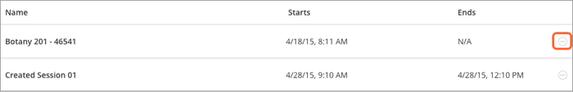
- From the Sessions screen, find a session.
- Select Session options, Edit settings, and Session Settings.
- Optionally, set these settings:
  - Allow recording downloads: If you want to let users download recordings, you can set this before the session and recording begins.
You can change this later, if you change your mind. You can choose this option at any time. Either before the session is delivered or anytime after the recording has been created.
  - Anonymize chat messages: You can make chat messages posted during the live session appear as anonymous posts in the recording.
Any recording made after selecting this option has anonymous chat messages. It does not apply to recordings made before selecting this option.
Chat Recordings are only available in the HTML5 player which is only available in Session Administrator System (SAS) , Learning Tools Interoperability (LTI), and Blackboard Collaborate ULTRA building block users at this time.
  - Allow users to join a session using a telephone: When selected all participants see an option in the Session menu to use their phone for audio during a session. If you don't select it, telephone is not available during the session.
More on telephony and calling into a session
  - Participants can only chat with moderators: Private chat is available by default. When selected participants can only chat privately with moderators. If you don't select it, participants can chat privately with any body else in the session.
  - Moderators supervise all private chats: When selected, moderators can see everything that is said in private chat channels. An alert appears at the top of the private chat channel informing users that the chat is being supervised. If you don't select it, you don't see the private chat channels.
This is only available to users with moderator access to the Scheduler, use Collaborate in an LTI compatible LMS, or use Blackboard Collaborate Ultra in their Blackboard Learn course at this time. Not sure which one you use? Jump to Schedule Sessions.

Settings you can change DURING a session
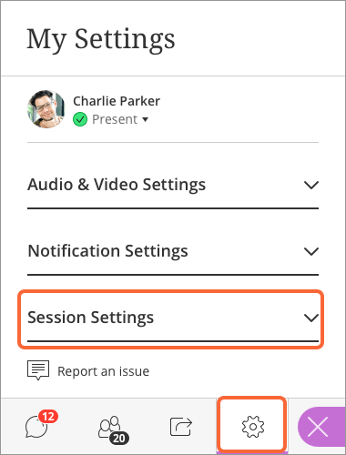
Moderators can change participant permissions any time before or during a session. Open the Collaborate panel and select My Settings. Select Session Settings.
Not sure where the Collaborate panel is? Jump to Find Your Way Around.
By default anyone with a participant role is allowed to show their profile picture, share their audio and video, post chat messages, and draw on the whiteboard and shared files.
Optionally, change these settings:
- Show profile picture for moderators only: If selected, participant profile pictures don't appear anywhere profile pictures are seen in the session. This includes in the Participants panel, chat, breakout groups, and on the main stage. The default avatar appears for participants instead.
- Share their audio: If selected, moderators can mute participants as needed. If not selected, only moderators and presenters can turn on their audio.
- Share their video: If not selected, only moderators and presenters can turn on their video.
- Post chat messages: If not selected, moderators and presenters can still use chat. Participants can't use chat but they can see any chat messages posted by moderators and presenters.
- Draw on whiteboards and files: If not selected, only moderators and presenters can draw on whiteboards.
If your session has over 250 participants, everything is off for participants by default and can't be changed. To learn more, see Large session settings.

Large session settings
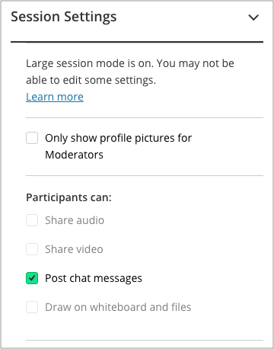
Large sessions in Collaborate have over 250 and up to 500 users in the session. This is a lot to manage. For this reason we've turned off some of the features that can be disruptive in a session with that many participants.
- Participant permissions: We turned off these participant permissions.
  - Share audio
  - Share video
  - Post chat messages
Moderators can choose to turn this on DURING a session.
  - Draw on whiteboards and files
The permissions are off for participants only. Moderators and presenters can still do all of these things.
- Breakout groups: We've also turned off breakout groups as the group is too large for small group collaboration.
If you expect over 250 participants in your session, you must submit a large session request to the Collaborate support team on Behind the Blackboard BEFORE the session begins.

What if I want to let participants chat or use their audio?
If you want participants to share their audio or video, post chat messages, or draw on whiteboards and files promote them to presenters or moderators.
You can also have all participants join as a presenter or moderator. If you do this during a large session, try and limit the number of users drawing on a whiteboard at once. Mute all users to limit the potential for disruption.
Source: https://help.blackboard.com/Collaborate/Ultra/Moderator/Get_Started/Session_Settings

Know the Tools
Know the tools. Use the tools.
With the Ultra experience of Collaborate you can do as little or as much as you want in a session.

Media space tools
Not sure where the media space is? Go to the Find Your Way Around topic under Getting Started.
Tool | Description
Audio | Turn your audio on. Lines through the microphone icon means that it is turned off. Select Share Audio to turn it on.  With your keyboard, press Alt + M to turn your microphone on and off.
Video | Turn your video on. Lines through the camera icon means that it is turned off. Select Share Video to turn it on.  With your keyboard, press Alt + C to turn your camera on and off.
Hand raise | Raise your hand to answer a question or get another moderator's attention. Select Raise Hand.  With your keyboard, press Alt + H.
Collaborate panel | Open the Collaborate panel.  More on navigating the Collaborate panel with your keyboard
Session menu | Open the Session menu.
Follow the speaker view | Switch to the follow-the-speaker view.
Grid view | Switch to the grid view.
Picture-in-picture | Change the focus of your screen. If shared content is on your main screen, switch to watching the speaker. Select the picture-in-picture to bring that content to your main screen.
Status | Show your status as away. Point to the green checkmark by your avatar image and select Set as Away. Select I'm back! when you return.  You can also update your status to give feedback during the session.

Session menu tools
Not sure where the Session menu is? Go to the Find Your Way Around topic under Getting Started.
Tool | Description
Start a recording | Moderators can start recording the session from the Session menu.
Use your phone | Use your phone for audio during a session.
Report an issue | Report an issue with the session.
Help | Go to Blackboard Collaborate help on help.blackboard.com.
Learn how to use Collaborate | Open tutorials on how to use Collaborate.
Leave session  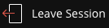 | Exit the session and complete a quick survey to tell us about your experience.
Close | Close the Session menu.

Collaborate panel tools
Not sure where the Collaborate panel is? Go to the Find Your Way Around topic under Getting Started.
Tool | Description
Chat | Chat with everyone in the session. Open the Collaborate panel and select Open Chat.  The moderator can turn chat off.  The emoji pack for Collaborate with the Ultra experience supports diversified emojis and Unicode 8 characters.  Use one of five supported skin tones on any human emoji. Add underscore, tone, and the supported tone number (1 through 5) to your emoji when typing. Don't forget the colons on either end of your emoji text.  Example: :wave_tone5:  Collaborate's chat history only has 50 messages displayed at any given time.  More on keyboard controls for chat history
Participants panel | View the list of participants. Open the Collaborate panel and Select Open Participants List.
Share Content | Moderators and presenters can share a blank whiteboard, an application, PDFs, PowerPoint® presentations, and images in GIF, JPEG and PNG formats.
My Settings | Add a profile image, set up your audio and video and your notifications. Open the Collaborate panel and select My Settings.
Close | Close the Collaborate panel.
Share Whiteboard | Moderators and presenters can share a blank whiteboard from the Share Content panel.
Share application | Moderators and presenters can share their entire desktop or a single open application from the Share Content panel.
Share files | Moderators and presenters can share PDFs, PowerPoint® presentations, and images in GIF, JPEG and PNG formats.
Polling  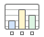 | Moderators can start and run polls during a session.
Breakout groups  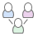 | Moderators can start and run breakout groups.
Options | Open the participant options menu.

Use these tools to edit and mark up shared files and the whiteboard.
Tool | Description
Select | Use the arrow to select an object on the whiteboard. After you select it you can resize, move, and delete it.
Pointer | Use the hand to point to different areas of the visible slide. Participants see wherever you are pointing on the slide.
Pencil | Use the pencil to draw free hand on the slide.
Shapes | Use the Shapes icon to draw a rectangle, ellipse, or a straight line. Your choice.
Text | Type text on the slide with the "T".
Clear | Use the eraser to undo everything.
View controls | Show or hide your zoom, fit, and size controls.
View controls opened | Zoom in, Zoom out, Best Fit, Actual size  Best fit takes advantage of your screen real estate. Content adjusts to be completely viewable in the available area. It displays as large as possible while keeping the aspect ratio intact.
Slide navigation controls | Move to the previous our next slide.  With your keyboard, press Alt + Page Down to move back a slide and Alt + Page Up to move forward a slide. On a Mac, press Alt + Fn + Down Arrow or Alt + Fn + Up Arrow.  Select the slide name to view all slides.
Stop | Stop sharing content.

Audio and network indicators
Tool | Description
On-air | Collaborate tells you when others in the session can see your video. If you see an eye, your video is the focus of everyone else's screen. If you see an eye while content is shared, others see your video as their picture-in-picture.
Audio status | See who is speaking and who has their microphone turned on. Microphones appear next to participants who have their audio turned on. A dark microphone is used to represent the current speaker. As with the follow-the-speaker view, the dark microphone moves to the current speaker as the discussion unfolds.
Network status | You can tell at-a-glance who is in your session and who might be having trouble connecting. Network indicators have been added to the Participants panel. These tell you when someone is in the process of joining your session, if users are connected, and how their connection is. Move your pointer over participants in the Participant panel to see the indicators. Move your pointer over the indicator to see network status information.
Source: https://help.blackboard.com/Collaborate/Ultra/Moderator/Get_Started/Use_The_Tools

Record a Session
Rewind and repeat!
Record your sessions so that your students can access presentations whenever they need them. Stop and restart whenever you need to, and when finished, post the session to your course page.
Recordings capture the audio, video, and any content that is shared during a session. Recordings also capture any real time captions or chat available during the session.
If you want chat messages to be anonymous in the recording, make sure you select that option in Session Settings before you start the session. To learn more, see Session Settings.
If there are more than one captions available during the session, the recording will capture only the first one. To learn more, see Live closed captioning.

Now Recording
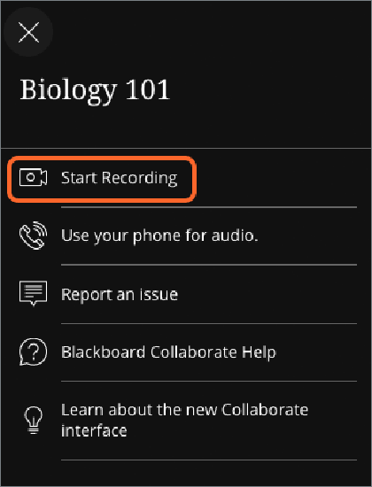
You can have multiple recordings during one session. If you decide to continue recording a session after you have stopped, a new recording is saved and added to the list of recordings for that session.
Open the Session menu and select Start Recording. The recording camera appears on with a red dot while recording is in progress.
To finish recording, open the Session menu and select Stop Recording.
If you are sharing a file, allow 8 seconds for the recording to include the shared file before moving on.

Now Viewing
Recorded sessions are saved as MP4s. Recordings include audio, any content shared or active speaker video, and the captions entered during the live session. If your session had more than one caption track, only the first available one is captured. Only moderators can record sessions.
Everyone can view the recordings from any device as often as they want. There are no view limits.
Recordings need to be converted into a playable format before viewing. The first time a recording is accessed the conversion begins. It may take a few minutes but once is has been done the recording can be viewed by everybody.

Recording player
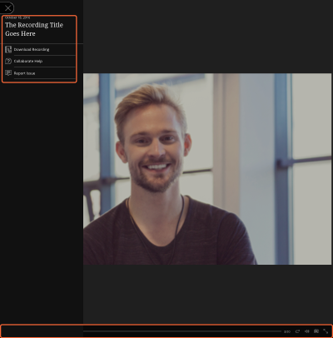
The recording player has the same look and feel as your Collaborate session. There is a Recording menu similar to the Session menu in your live sessions and recording playback controls.
The recording player is an HTML5 player. It is only available in Session Administrator System (SAS) , Learning Tools Interoperability (LTI), and Blackboard Collaborate ULTRA building block users at this time.
- Recording menu: Open the Recording menu at the top left of your screen. From here you can download the full recording, download caption transcripts, download chat transcripts, get extra help, or report an issue if you are having trouble with the recording.
- Captions: Captions are only available in recordings when captions were used during the live session. Closed captions are on in the recording by default. Select Closed Captions in the playback controls to turn off the captions or adjust the size of the caption font.
You can also download a transcript for the captions from the Recording menu.
- Playback controls: The intuitive playback controls allow you to navigate through the recording the way you want.
  - Pause: With your keyboard, press the Spacebar to pause and play the recording.
  - Repeat/Forward: With your keyboard, press the Left and Right arrow keys to repeat or skip the recording by 10 seconds.
  - Progress: Slide the marker on the progress bar to move through the recording. With a keyboard press Shift + Left arrow or Shift + Right arrow to repeat or skip the recording by 10 seconds.
  - Volume: With your keyboard, press the Up and Down arrow keys to increase and decrease the volume by 5%.
  - Closed captions: Select Closed captions to view the captions with the recordings. You can also download a transcript of the captions from the Recording menu.
- Chat messages: Open the Chat panel at the bottom right of your screen to see the complete chat history of the recorded session. To learn more, see Chat messages in recordings.
Don't worry, we'll walk you through it. When you first open the recording player we'll show you where everything you need is.

Chat messages in recordings
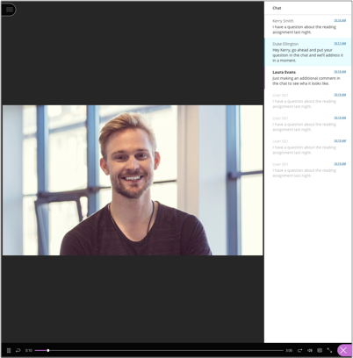
Open the Chat panel at the bottom right of your screen to see the complete chat history of the recorded session.
As the recording plays the chat messages posted highlight so you can see what was being said during that moment. You can also navigate to a specific location in the recording by selecting a chat message time stamp. If a message is faded, you haven't reached that part of the recording yet.
Moderators can also make chat messages in the recording anonymous from the session settings. This needs to be done before starting the live session and recording it. To learn more, see Session Settings for moderators.
Chat Recordings are only available in the HTML5 recording player which is only available in Session Administrator System (SAS) , Learning Tools Interoperability (LTI), and Blackboard Collaborate ULTRA building block users at this time. Not sure what your course is? Jump to Use in Your Course.

Chat transcripts
You can download chat transcripts from the Recording menu. This is only available in the recording player.

How do I find the recordings?
Recordings are saved on the same page you joined your session from.
- From a web link, log into Collaborate and select Recordings.
- From a Moodlerooms course, select the Collaborate activity to view the recordings.
- From a Blackboard Learn course, select Course Tools and Collaborate.
- From an Learning Tools Interoperability® (LTI) compliant Learning Management System (LMS), go to Collaborate and select Recordings.
Not sure what your course is? Jump to Use in Your Course.

Can I download recordings?
Yes. If the moderator has allowed session recording downloads, you can now download recordings from the same place you view the recordings as well as on the recording play back page.
Recorded chat messages are only available in the recording player. They are not available in the downloaded MP4 file.

Allow users to download recordings
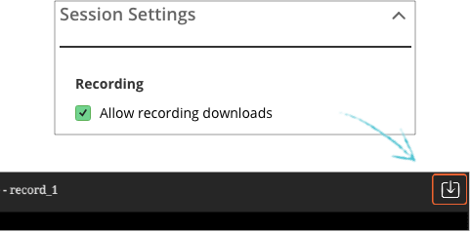
You must allow session recording downloads for each session. Open a session's Session Settings and check Allow download recording. Any recordings made in this session can be downloaded while downloads are allowed.
Downloads are only available to Session Administrator System (SAS) and Learning Tools Interoperability® (LTI) users at this time.

Recording and storage
More on Collaborate with the Ultra experience file and recording storage on Behind the Blackboard (available in English only)
Source: https://help.blackboard.com/Collaborate/Ultra/Moderator/Get_Started/Record_Sessions

Manage Participants

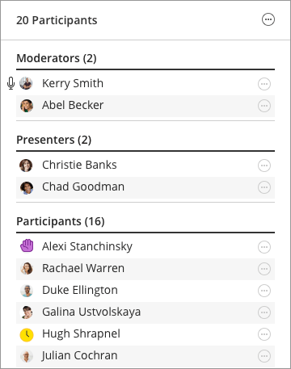
Where can I find participants?
Open the Participants panel to view all participants. Open the Collaborate panel and select Participants.
Not sure where to find the Collaborate panel? Jump to Find Your Way Around.
At-a-glance you see:
- The roles of each participant. We've grouped participants by roles to make it easier to see who can do what in the session.
- Participants with their hand raised. Those with their hand raised appear at the top of their role list.
- Participants' status or feedback.
- Participants with their microphone turned on.
Browse through the list of participants or open More options at the top of the panel and select Search.
Point to a participant to view more information, such as their network connection. Moderators can select Moderator controls next to a participant's name to promote them, mute them, or remove them.
If you are using keyboard navigation, press Tab from the top of the panel to find "Access list of participants". "Access list of participants" is not visible unless the focus is on it. Press Spacebar to activate it. Moderators can now use Tab to move through the Moderator controls for each participant.

Keep the Participants panel open at all times
You can leave the Participants panel open all the time. Chat with others and see everyone in the session at the same time. You can tell who is away, has their microphone on or is having network connection trouble. All while chatting and participating in the session.
If you need to detach the Participants panel to keep it open. There are two ways to do this:
- Open the Collaborate panel. Drag-and-drop the Participants icon to the main stage.
- Open the Collaborate panel and select Participants. Select More options at the top of the panel. Select Detach Panel.
The main stage adjusts so you can still see everything on it. Any video, content, whiteboard and application shared are moved to the left to make room for the panel.
Close the panel any time. Select More options at the top of the panel. Select Merge Panel.

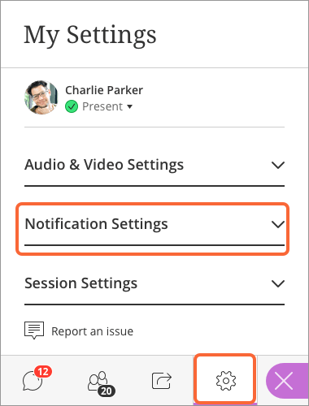
Notification settings

Do you want to be notified when someone joins or leaves a session? How about when posts a chat message? Do you prefer an audio or visual notification?
Open the Collaborate panel and select My Settings. Select Notifications Settings.
By default all of the settings are turned on. These settings only turn on/off the notification banners and sounds.
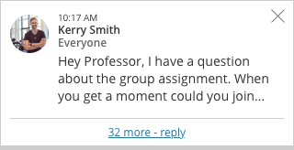
If you turn these notifications off, you still see:
- A joining status for the participant in the Participants panel.
- The number of new messages posted on the chat icon.
- Hands raised in the Participants panel.
- The red light over the recording icon when you are recording.
These are personal settings. Everyone sets their own notifications. Only moderators and presenters can set notifications for when someone raises their hand.

Mute participants
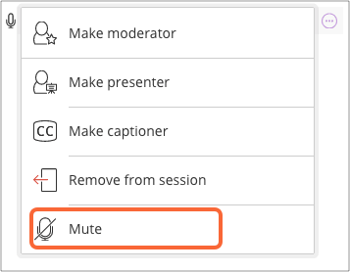
Moderators can mute individual participants or everyone in a session. This includes participants using the Blackboard app or the Blackboard Instructor app.
- Mute individual participants:
  - From the Participants panel, point to a participant with their audio on.
  - Select Moderator controls.
  - Select Mute.
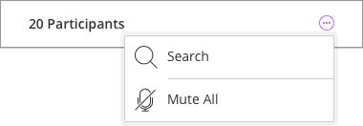
- Mute all participants:
  - Select More options at the top of the Participants panel.
  - Select Mute All.

Muted participants see a notification telling them that the moderator has muted their microphone.
Note: Participants can turn their microphone back on after being muted.

Manage raised hands
Participants can raise their hands any time during your session. They do this to get your attention or ask a question. You can choose to call on them now or close the notification and call on them later.
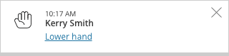
An image of a hand appears beside participants with their hand raised. Those participants are also brought to the top of their role list in the Participants panel so they aren't forgotten and are easily found.
How the notification looks
How it looks in the Participants panel
- Select Lower hand in the notification to remove raised hands.
- Close the notification to leave the hand raised and come back to later.
You can also lower hands from the Participants panel. Point to the participant with their hand raised and select Moderator controls. Select Lower hand.
By default you are notified when someone raises their hand. If you do not see hand raise notifications when participants raise their hands, check your Notification Settings in My Settings.

Participant permissions
Do you want to mute everyone with the role participant while a guest speaker is presenting? Can participants use the whiteboard?
Decide who can do what in Session Settings any time before or during a session. Open the Collaborate panel and select My Settings. Select Session Settings.
Not sure where the Collaborate panel is? Jump to Find Your Way Around.
By default anyone with a participant role is allowed to show their profile picture, share their audio and video, post chat messages, and draw on the whiteboard and shared files.
More on Session Settings

Promote participants
Are you sharing moderator or presenter roles with someone in your presentation? You can promote participants to other roles anytime. More on the different roles
- Point to a participant in the Participants panel
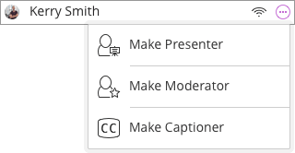
- Select Moderator controls.
- Select the role you want to make that participant.

Promote all participants
You can also have all participants join as presenters or moderators. From the list of Sessions, find a session.
- Select Session options
- Edit settings.
- Select Presenter or Moderator in the Guest Role menu.
This is only available to users with moderator access to the Scheduler, use Collaborate in an LTI compatible LMS, or use Blackboard Collaborate Ultra in their Blackboard Learn course at this time. Not sure which one you use? Jump to Schedule Sessions.

What can the different roles do?
Users can be moderators, presenters, participants, and captioners in the Ultra experience.
- Moderator: Moderators have full control over all content being shared. They can make any participant a presenter or a moderator. Moderators see hand raise notifications and can lower hands. They can remove participants from a session, but they cannot remove other moderators. Moderators can set the session settings, including deciding what participants can and can't do.
- Presenter: The presenter role is designed to allow students to present without giving them full moderator privileges. Presenters can upload, share, edit, and stop sharing content. They can also see hand raise notifications and can lower hands.
- Participant: Participants can enable and disable notifications, such as when participants enter and leave a session or when someone has posted something to the chat. Moderators decide if participants share audio and video, chat, and draw on the whiteboard or shared files.
More on participant permissions
- Captioner: The captioner role is designed to provide an accessible learning experience for students who are deaf or hard of hearing, as well as for students whose native language is different from the moderator's. A participant is assigned this role by a moderator. The captioner is given an area to type what is being said. Other participants can view what the captioner is typing in real time. You can have multiple captioners for multiple languages.
More on being a captioner

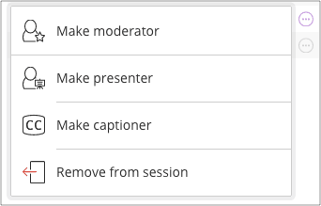
Remove participants
Remove a participant any time you need.
Point to a participant in the Participants panel and select Moderator controls. Select Remove from session.

Can a participant rejoin?
Yes. Participants are notified about the disconnection, and they are allowed to reconnect.

Session attendance report
The Session attendance report tells you an overview of when participants joined and left your sessions. It also gives you an idea of how long participants were present in the session on average.
If you have used a session more than once, there is a report for each time it was used.
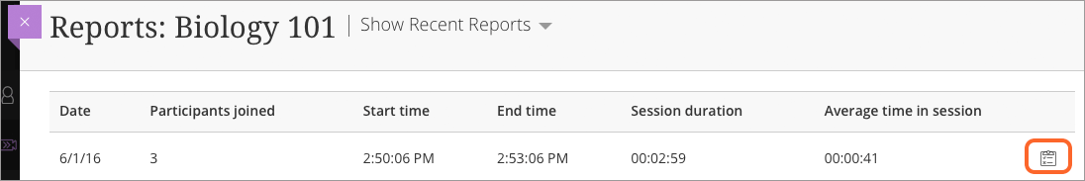
Select View report to see the full report. See when each participant joined and left the session. With this knowledge, check in with individual participants to see if they were having any technical issues or need a quick review of what was presented and discussed.
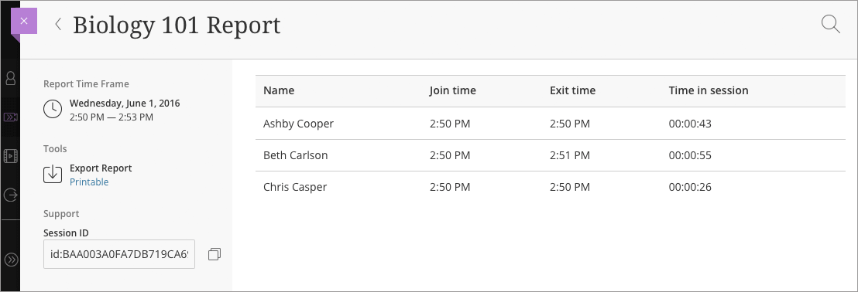

Where to I find session reports?
View reports from the list of sessions in your Blackboard Collaborate tool.
- Find the session you want to see a report on, and select the Sessions options menu.
- Select View reports.
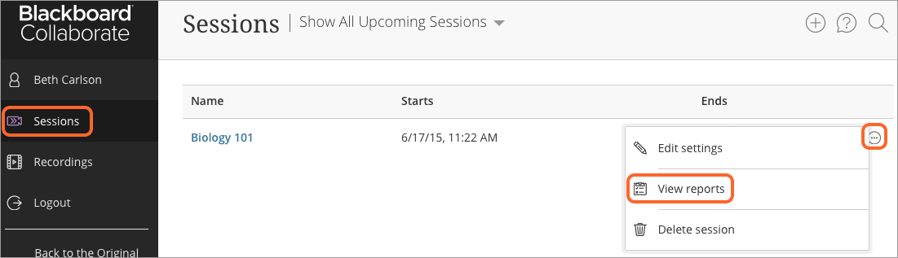
If you don't see View reports, it is not available on your system.

Print reports
Create a printable version of the full report to print.
- Find the session you want the report of and select View reports.
- Find the report you want to print and select View report.
- Select Printable.
- Print the page.
The printable version of the report includes all participants for the date range selected. If you filter your report by user and select Printable, the printable version shows all users. Not just the one searched for.

Filter reports
Filter your report list by date range and participant.
- By date range: From the main Reports page, select Show Reports In A Range from the Show Reports menu.
- By participant: From the full report page, select Search. Type the name of the participant you are looking for.

What is the Session ID for?
The Session ID in the report is a unique session identifier. It includes information Blackboard support can use to troubleshoot issues with the session.
- Submit a case on Behind the Blackboard (available in English only)
- Include the session identifier in the Description field of the case.

Source: https://help.blackboard.com/Collaborate/Ultra/Moderator/Manage_Participants#manage-raised-hands

Use Audio and Video

Get set up
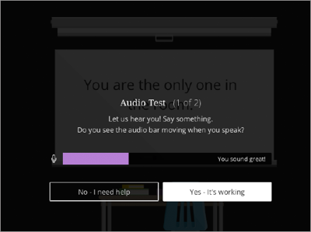
You must give the browser permission to use audio and video to participate in a session. This is necessary so that you are seen and heard.
You'll be asked to do this when you first join a session or when you first go to share your audio or video.
It's OK if you're not ready to do this right away. You can set up audio and video at any time in My Settings.
- Open the Collaborate panel and select My Settings.
- Select Set Up your Camera and Microphone.
You can use your phone for audio. To learn more, see Call Into a Session.
- Choose the microphone you want to use. Collaborate tells you that you sound great when it is receiving your audio. Select Yes, it's workingto proceed.
- Choose the camera you want to use. Collaborate tells you that you look great when it is receiving your video. Select Yes, it's working to proceed.
By default, you are hidden and muted after you complete the setup. Select the microphone and camera icons to begin full meeting participation.
With your keyboard, press Alt + M to turn your microphone on and off. Press Alt + C to turn your camera on and off.
Adjust your speaker and microphone volume any time in My Settings.
Having trouble setting up your audio and video with JAWS? Jump to Audio Set Up with Jaws in Google ChromeTM. Having trouble with VoiceOver? Jump to Audio Set Up with VoiceOver.

Let others hear and see you
Select the microphone and video camera icons any time during a meeting to turn them on or off.
With your keyboard, press Alt + M to turn your microphone on and off. Press Alt + C to turn your camera on and off.
The microphone automatically turns on after you enable it, but you will get to preview how you'll look on screen before sharing your video.
Moderators can mute participants anytime during the session. You are notified, if a moderator has muted you.
Want to use your phone for audio? Jump to Call into a Session.

Follow the speaker
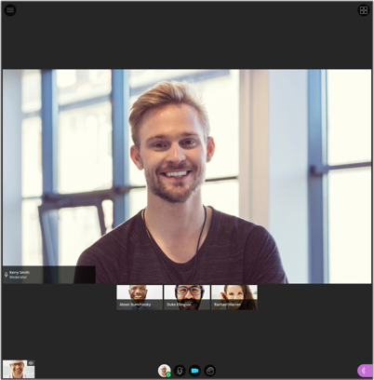
As the discussion unfolds, the person speaking appears in the center of the screen. Select Grid View to see more than one participant.
You can only switch views when using ChromeTM and Firefox® (version 49+).
Microphones appear next to any participants who have their microphone or phone audio turned on. A dark microphone is used to represent the current speaker. It moves to the current speaker as the discussion unfolds.

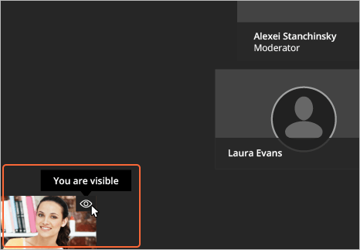
Know when you are "on air"
Collaborate tells you when others in the session can see your video. If you see your video with an eye, others see your video in the center of their screen. If you see an eye while content is shared, others see your video as their picture-in-picture.

Source: https://help.blackboard.com/Collaborate/Ultra/Moderator/Get_Started/Use_Audio_And_Video

Collaborate Breakout Rooms
To facilitate small group collaboration, you can create breakout groups that are separate from the main room and assign participants to them.
If your session has over 250 attendees in it, breakout groups is turned off.
Breakout groups requires you use version 52 of the ChromeTM browser or Firefox® versions 49 and higher.
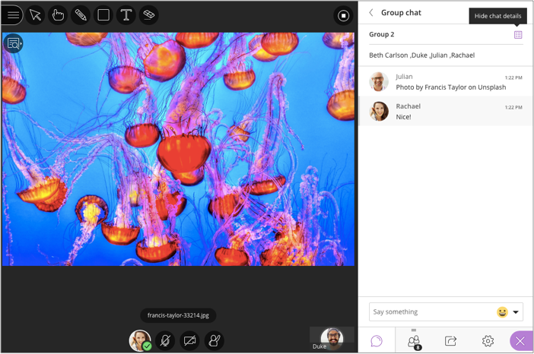
Breakout groups have their own private audio, video, whiteboard, application sharing, and chat. Any collaboration that takes place in a group is independent of the Main room (and other groups).
What is said or viewed in a breakout room isn't captured in recordings.

Watch a video about breakout groups
Video: Breakout Groups in Blackboard Collaborate

Start breakout groups
You can choose to have Collaborate create and randomly assign breakout groups for you. Or you can create the groups yourself.
- Open the Share Content panel from the Collaborate panel.
Not sure where the Collaborate panel is? Jump to Find Your Way Around.
- Select Breakout Groups.
- Assign groups. Select Randomly assign or Custom assignment.
  - Randomly assign: Collaborate creates groups and randomly assigns participants for you.
Randomly assign is only available when there are four or more people are in the room.
    - If you want to be in a group, select Include moderators in group assignment.
    - You can change how many participants are in each group. Select the number of groups from the Number of Groups menu.
    - If you don't like how the participants are grouped, select Reassign participants.
  - Custom assignment: Create your own groups.
    - Assign participants to a group. You can select the participants options menu and select the group. You can also select the participant and drag them to the right group.
    - Select Create a new group to add more groups.
You can create up to 20 groups. Breakout groups is only available in sessions with 250 or fewer attendees. There is no limit to the number of attendees you can put in each group. However, we recommend spreading attendees out evenly over your groups.
- Optionally, select Allow participants to switch groups, if you want participants to be able to move to another group on their own.
- Select Start.

What can participants do in breakout groups?
Breakout groups are designed for group collaboration. Every participant in the group is a presenter. This means that all participants can share the whiteboard, files, and applications with the rest of their group.
Content shared in a breakout group is not available when breakout groups end. Consider suggesting participants record their collaboration in some way. Example: A screen capture of anything they have shared and collaborated on.
Make sure your browser supports application sharing
More on presenter permissions

Monitor groups
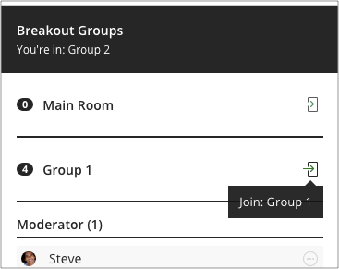
After breakout groups are started you can move between groups to monitor them. If you assigned yourself to a group, you see and hear what others in the group are doing. This includes any shared content, audio, video, and chat.
If you want to see how the other groups are doing, you need to join those groups. From the Participantspanel, select Join group.
Group chats are private to the group. The Everyone chat room is open to everyone, no matter what group you are in. As a moderator you also have a moderator only chat room.

Move participants to another group
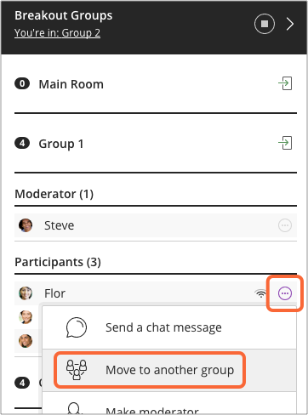
Moderators can move themselves between groups by selecting Join Group in the participants panel. You can also move other participants.
- From the Participants panel, find a participant and select Moderator controls.
- Select Move to another group. This opens the Breakout groups panel.
- Move the participant to another group. There are two ways you can do this.
  - Select the participant's options menu and select the group.
  - Select the participant and drag them to the new group.
- Select Update.

Can I remove someone from a session?
Yes. You can choose to move them back to the main room or to another group. Or you can choose to remove them completely from a session. Open the participant's options menu from the Participants panel. Select Remove from session.

What happens if another moderator makes changes to the groups?
If another moderator makes changes to the group before you select Update, your changes are lost. You are notified that another moderator made changes.

End breakout groups
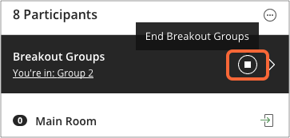
When you want to stop breakout groups and bring everybody back to the main room,
- select End breakout groups.
- You can find this
  - at the top of the Participants panel or
  - beside Breakout groups in the Share Content panel.
Participants panel
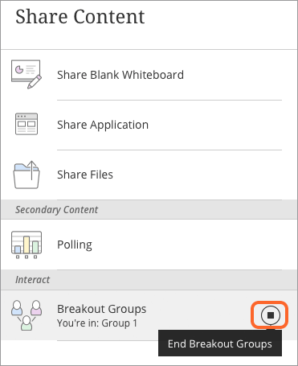
After you select End breakout groups, all participants are moved back to the main room.
Share Content panel

After the groups have ended everything shared in a group is not available in the main room. Give your participants a few minutes warning that you are ending the breakout groups. Give them time to take a screen capture, or record in some other way, what they were working on before ending the groups.

Source: https://help.blackboard.com/Collaborate/Ultra/Moderator/Collaboration/Breakout_groups

Collaborate Polls
Polls are great to engage your participants and keep them interested. They have so many uses.
- Keep your participants' attention by giving them opportunities to participate.
- Start a discussion by asking your participants their opinion on something.
- Ask questions to see how well they understood what you presented.
- Or use reflective questions to help them retain what you presented.
Participants respond to your poll by selecting one of up to five responses. You decide how many choices participants see.
Polling is not supported in the Bb Student app. Any students using Bb Student won't be able to participate in polls.

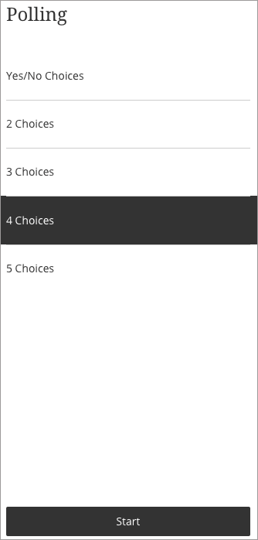
Create polls
You can use a poll that gives participants yes or no as their response choices. You can also select to give participants two, three, four, or five responses to choose from.
- Open the Collaborate panel.
- Select Share content.
- Select Polling.
- Select the type of poll you want to use.
If you choose one of the numbered choice polls, participants see numbers as their choices. Tell your participants what each number represents. Share an image, PowerPoint®, or the whiteboard to show your poll question and the numbered choices with related responses.
Example: If you choose the 3 Choices poll and have choices of 1. Yes, 2. No, and 3. Maybe, participants can choose between 1, 2, and 3 as their response.
- Select Start.

Monitor your poll
Immediately after starting your poll, you can see an overview of poll responses. This overview gives you a response count for each choice. It even tells you how many participants haven't responded yet. If you want to see how each participant's response, or even who hasn't responded, go to the Participants panel.
Moderators can also respond to the poll. For this reason, you are also counted in the No Response count as well.
The polling overview doesn't stay open. Open it by selecting Polling.
From here you can choose to show responses to all participants or stop the poll.

Show responses to participants
Select Polling to open the poll overview. Select Show Responses to show the responses to all participants. Participants see the overview count of the responses only.
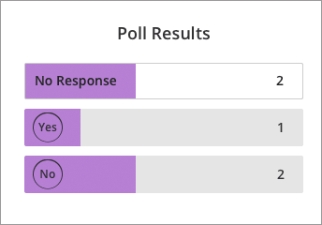
Select Hide Responses to hide the results from participants.
Participant view
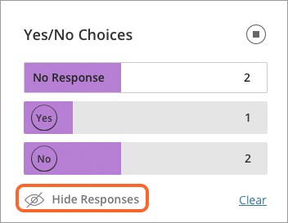
Moderator view

What do participants see?
After you start the poll participants are asked to make a choice. All they see are their response choices.
The choices disappear so they don't block anything on the main stage. Participants can select Polling to open the choices again.
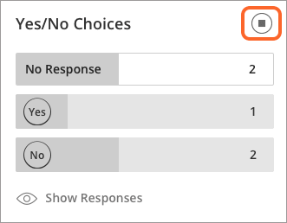
Participant see their own choice after they make a choice. They don't see the poll results unless you share the responses. Participants never see how anyone else has responded.

How do I stop a poll?

Select Polling to open the poll overview. Select Stop to stop the poll.

Source: https://help.blackboard.com/Collaborate/Ultra/Moderator/Collaboration/Polling

Raise Hands
Manage raised hands
Participants can raise their hands any time during your session. Reasons to Raise Hand:
- Gain your attention
- Ask a question.
- You can choose to call on them now or close the notification and call on them later.
An image of a hand appears beside participants with their hand raised. Those participants are also brought to the top of their role list in the Participants panel so they aren't forgotten and are easily found.
How it looks in the Participants panel
How the notification looks
- Select Lower hand in the notification to remove raised hands.
- Close the notification to leave the hand raised and come back to later.
You can also lower hands from the Participants panel. Point to the participant with their hand raised and select Moderator controls. Select Lower hand.
By default you are notified when someone raises their hand. If you do not see hand raise notifications when participants raise their hands, check your Notification Settings in My Settings.
Source: https://help.blackboard.com/Collaborate/Ultra/Moderator/Manage_Participants#manage-raised-hands

Chat Panel
Use Chat to communicate and collaborate with others in your session. You can post chat messages to everyone in the session or to individuals.
Moderators can turn chat off or on in their sessions.

How do I know when there are new chat comments?
Collaborate uses notifications that appear on your screen to let you know what's happening in your session. These notifications tell you when there are new chat comments.
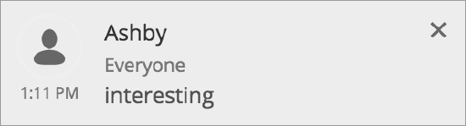
The notification stays on the screen for a few seconds then disappears. It tells you if you have a new chat message, if there are more than one, and what chat channel the comment is in.
If you have the chat panel open, you'll also see a new comment alert in the Chat with: menu.
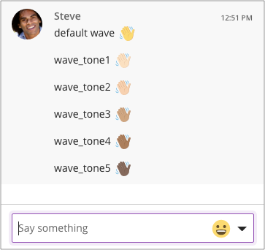

Chat emoji
The emoji pack for Collaborate with the Ultra experience supports diversified emojis and Unicode 8 characters.
Use one of five supported skin tones on any human emoji. Add underscore, tone, and the supported tone number (1 through 5) to your emoji when typing. Don't forget the colons on either end of your emoji text.
Example: :wave_tone5:

Chat history
Collaborate's chat history only has 50 messages displayed at any given time. Scroll through the messages or use the hidden keyboard controls at the top of the Chat panel if you use a keyboard to navigate.
More on navigating chat history with your keyboard

Private chat
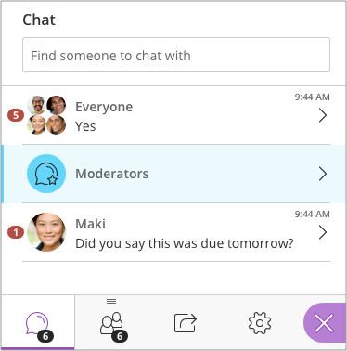
Chat privately with anybody else in your session.
Private chat does not work with the student Blackboard app at this time.
By default you see the Everyone chat when you first open Chat. Select Previous Panel by the Everyoneheading. Then just type the name of the person you want to chat with and start chatting.
Be careful what you say in your private chats! Moderators may supervise private chats between participants to monitor for inappropriate language or bullying. There is a warning when moderators are supervising.
Moderators have their own private chat already created for them. Participants won't see the Moderators chat channel.
If moderators want to supervise private chat, the option must be selected BEFORE the session starts. See Session Settings for more on settings you can set before and during a session.
Only the Everyone chat is included in session recordings.

Watch a video about private chat
This video explains the private chat.
Video: Private chat

Make your sessions more engaging with Chat!
Most students are extremely comfortable with some form of text-based communication. You may see students participate who might be hesitant to speak up in audio/video settings.
Open the Collaborate panel and select Open Chat to start chatting.
Not sure where the Collaborate panel is? Jump to Find Your Way Around.

Allow chatting in your sessions
Chat may not be on when you first enter your session. You may need to turn it on.
Open the Collaborate panel and select My Settings. Select Session Settings and select Post chat messages.
Source: https://help.blackboard.com/Collaborate/Ultra/Moderator/Get_Started/Use_Chat

Writing on Whiteboard and Sharing Content
Blackboard Collaborate allows you to exchange information and ideas with session participants. Three features exist on the collaboration toolbar to help you do this.
Each represents a mode in the content area. You can see the content of only one mode at a time. On the collaboration toolbar, the currently selected mode's icon appears in color.
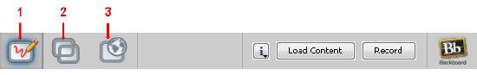
- Whiteboard: Share presentations and drawings.
- Application Sharing: Share individual applications or your entire desktop.
- Web Tour: Share web pages.

Share Applications
Application Sharing allows a Moderator or Participant to share applications or their entire desktop with other attendees.
Learn more about using application sharing (available in English only)

Load Content
Various formats of content load into a web conferencing session. Learn more about how to upload a PowerPoint file to the Blackboard Collaborate Whiteboard:
Loading PowerPoint Quick Reference Guide (available in English only)

Take Users on a Web Tour
Web Tour allows Moderators to take Participants to a series of websites via an embedded browser window within the Blackboard Collaborate content window.
Web Tour Quick Reference Guide (available in English only)

Switch Modes
Click on the appropriate icon to switch modes.
- The whiteboard content is persistent. The content remains when you move to another mode and then return to the whiteboard.
- Application sharing content is also persistent. However, when you return, you need to click Resume Sharing so that you can see what you were sharing.
- If you leave a web tour, you need to type or paste the URL again to return to the web tour.

Roles and Permissions
- Moderators can switch to all modes.
- Participants with application sharing permission can switch to application sharing mode and back to whiteboard mode.
- Participants with web tour permission can switch to web tour mode and back to whiteboard mode.
Participants who have whiteboard permission, but not application sharing or web tour permission cannot switch to whiteboard mode from either of the other two modes. This safeguards against participants switching modes during someone else's web tour or application sharing presentation.
When you have permission to switch modes, be careful not to switch modes when someone else is presenting content. Everyone in the session will follow you to the new mode.
Source: https://help.blackboard.com/Collaborate/v12/Moderator/Conduct_a_Session/Share_Content#load-content

Share files
Upload GIF, JPEG and PNG images, PDF files, or PowerPoint presentations of 60MB or lower to your session.
Screen reader users can access text from PowerPoint and PDF files shared in the session. This provides an easy way to follow along as slides change. Moderators and presenters must select Share Files and upload the files to Collaborate for screen readers to access the text.
Select Add Files Here or drag a file into the box to upload it. Select Share Now when you're ready for students to see the file.
You can prep for class at the beginning of the week, or even at the start of the semester! After creating a session, you can open it any time and load the files you want to share. These files stay in the session until deleted by a moderator. Load them once and reuse them as often as you want.
You can choose to allow participants to mark up your shared file during a session in Session Settings. Open the Collaborate panel and select My Settings. Go to Session Settings and make your choice.
If you are recording your session, allow 8 seconds for the recording to include your shared file before moving on.
Source: https://help.blackboard.com/Collaborate/Ultra/Moderator/Share_Content#share-files

